Access Statement for Redwings Aylsham
Introduction
Redwings Aylsham is located just outside the small town of Aylsham, just off the A140 in stunning North Norfolk. It’s approximately 13 miles from Norwich City and 11 miles from Cromer. You can meet dozens of rescued horses and ponies at the centre for free and learn about all our other equine residents who live at other Redwings centres across the country.
The centre is on mainly level ground with two relatively steep inclines, that could be avoided. Redwings Aylsham is also a member of the Visitor Attraction Quality Assurance Scheme. We can provide a wheelchair to access most of the paddocks.
We look forward to welcoming you to the centre. If you have any queries or require assistance, please phone 01508 505246 or email info@redwings.co.uk
Pre-Arrival
- The nearest railway stations are North Walsham (8 miles) and Cromer (12 miles).
- We have a wheelchair available, disabled access toilet, and ramps to make the whole centre accessible.
- There are always staff on hand to assist our visitors.
Car Parking
- There are around 20 car parking spaces, with 2 spaces reserved for blue badge parking a few metres from the entrance to the Visitor Centre. The surface is at a very slight angle and is compacted hardcore and gravel.
- There is overflow parking for approximately 60 cars on a sloped, uneven grass area in dry conditions. All parking is free.
- Staff at the reception desk can see approaching visitors and give assistance.
- The entrance to the visitor centre is sloping. The main double doors are full length glass doors and can be opened individually.
- When both doors are open the width is 2050mm.
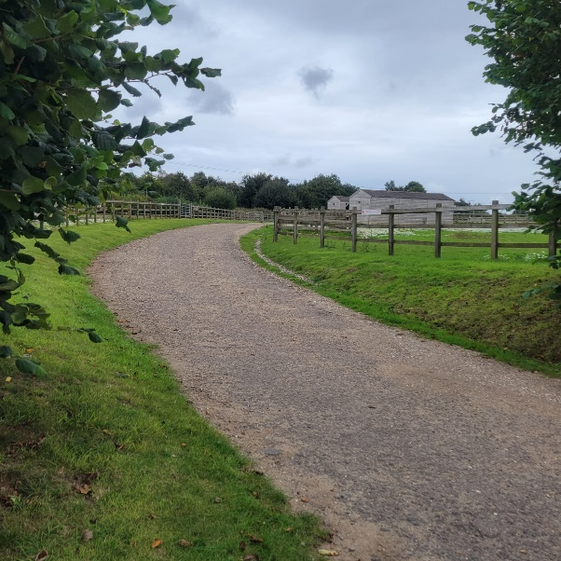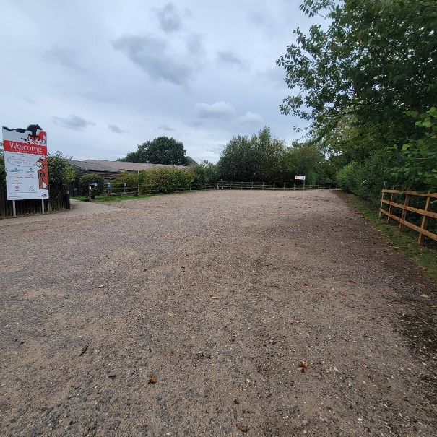
Entrance track Main car park
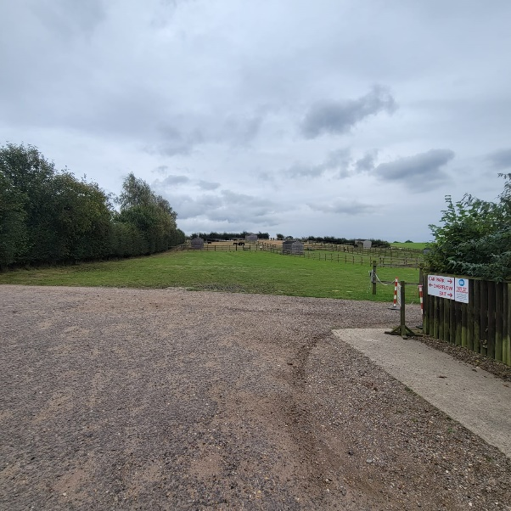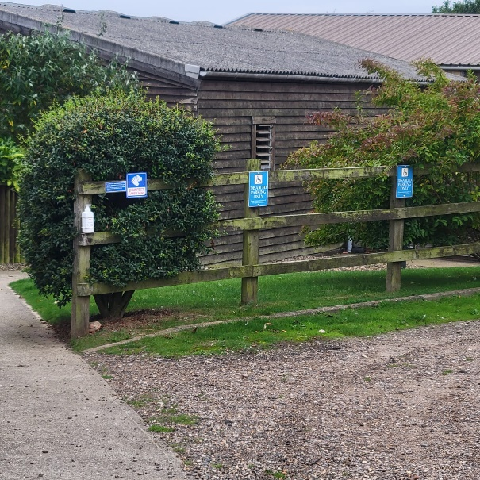
Main car park, looking at overflow car park Accessible parking

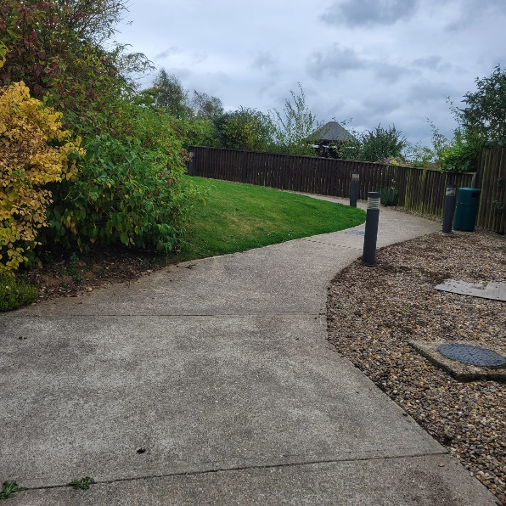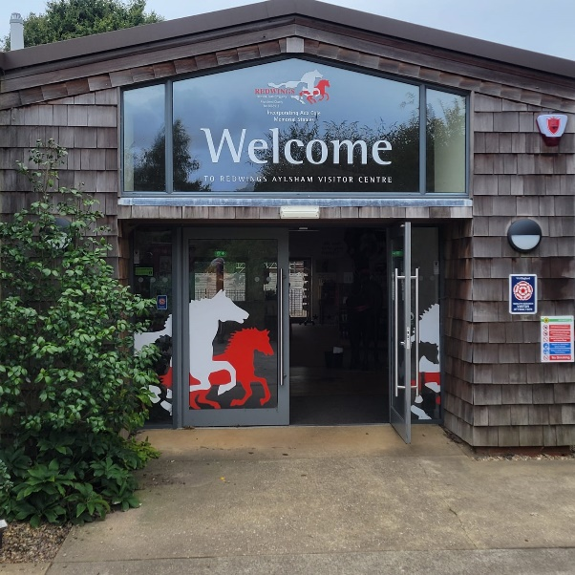
Path from car park to entrance Welcome doors

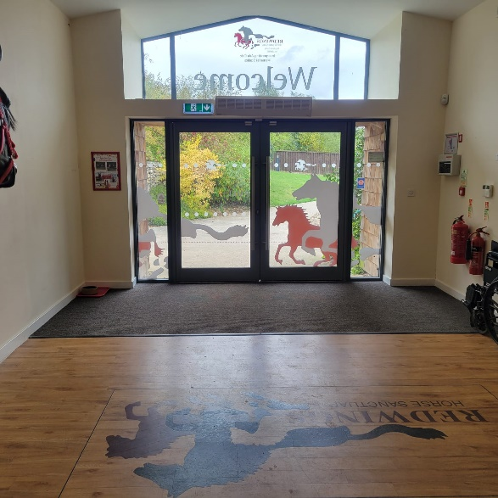
Inside the welcome doors
Main Entrance & Reception
• The area around the front desk provides ample room for small groups or wheelchair users. The reception desk is directly in front of the Visitor Centre entrance.
• The Visitor Centre is open plan. There is a gift shop and reception area with a café to the left. The floor is flat and on one level. Lighting is provided as strip lights.
• Seating is available in the café area.
• There is no hearing loop system but plenty of signage showing exits, fire exits, fire assembly points and the smoking point.
Toilets
- WC and washroom facilities are to the rear of the VC and accessible from within the VC and from outside.
  - From the outside, there is an internal step.
- The width of the door to the accessible toilet is 850mm and the height of the WC from the floor is 480mm.
- There is a red alarm cord which will activate an alarm outside the WC.
- There are baby-changing facilities in the accessible toilet.
- Electric hand driers are in situ. These can be turned off on request.
- The accessible toilet area offers hand towels in addition to the electric hand drier.
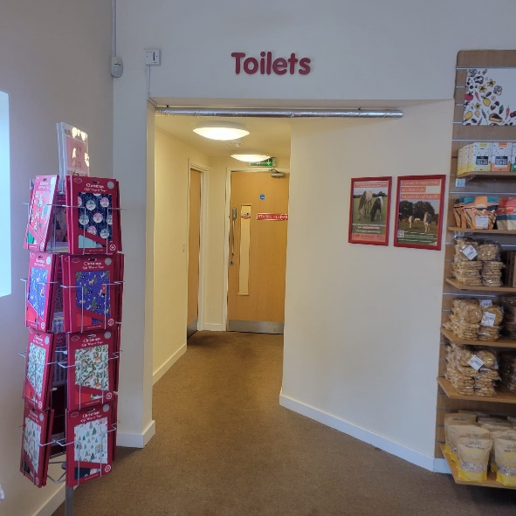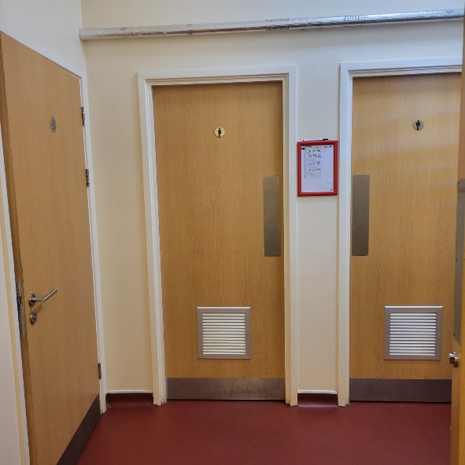
Access to toilets from gift shop Toilet doors
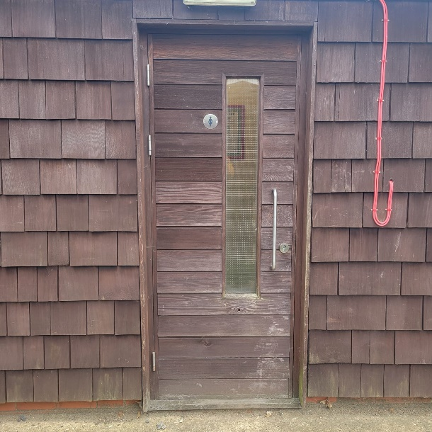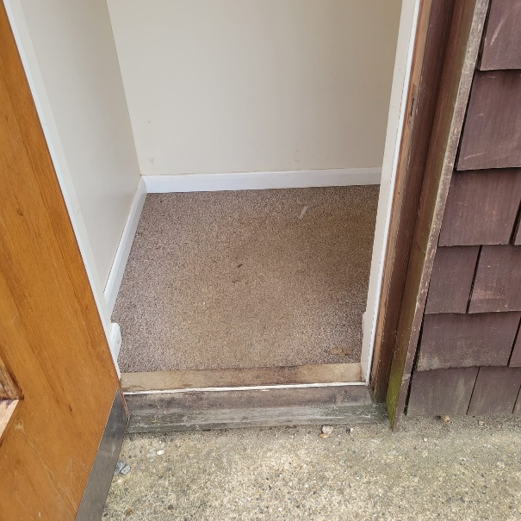
Outdoor access to the toilets Outdoor entrance into the toilets
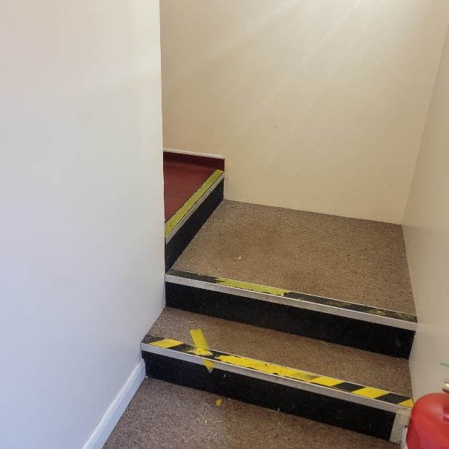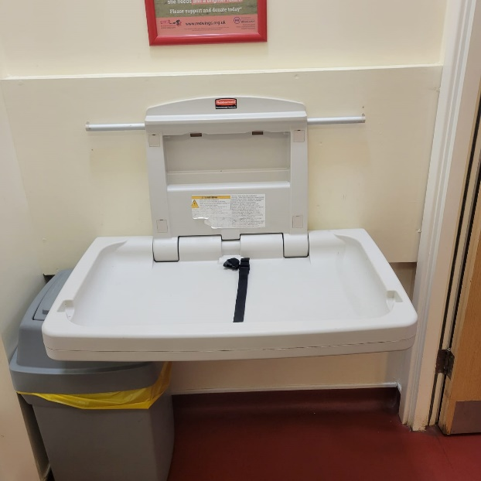
Steps into ladies’ toilets from outdoor access Baby changing table
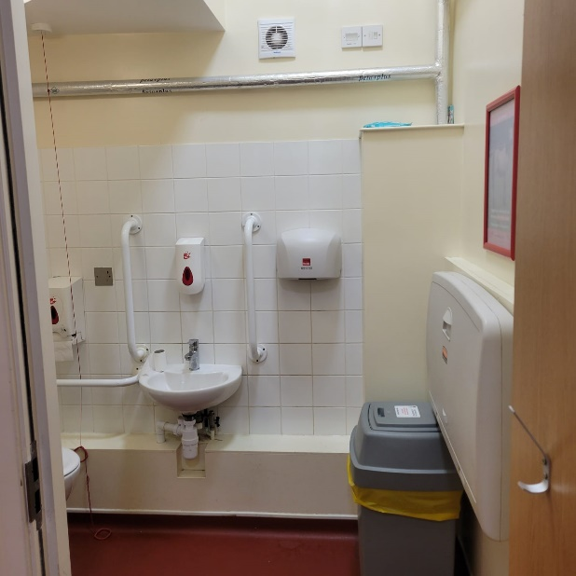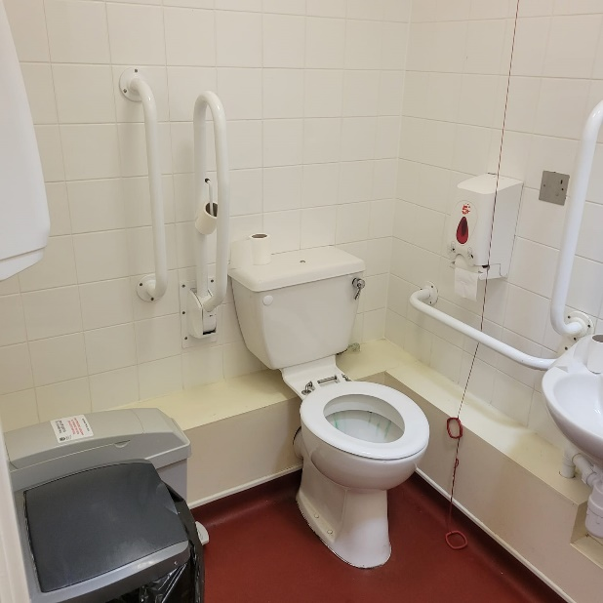
Accessible toilet Accessible toilet

Catering
- There is a café in the Visitor Centre providing refreshments and food and on the same level as the gift shop and reception area.
- The café area is large, and tables can be moved if required to accommodate visitors with access needs.
- The chairs are 440mm high and tables 720mm high with a clear space underneath of 710mm.
- Menus are on most tables and there is a menu blackboard. The menu can be read to visitors if required.
- The gift shop is accessible.
- There is additional seating on the patio area outside the Visitor Centre which can be accessed via sliding patio doors. The patio is partially shaded by the balcony above.
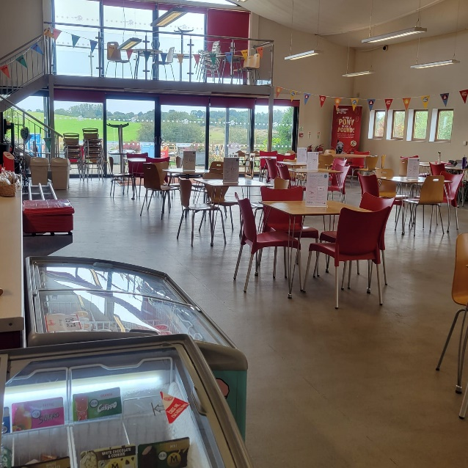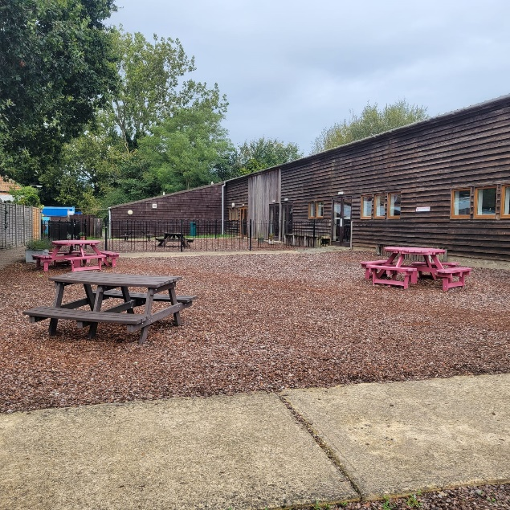
Indoor café seating Outdoor seating

Grounds & Gardens
- The walkways through most of the site are accessible by wheelchair and the route indicated by directional signage. Some pathways, including those on the nature walk, are grass.
- Guidance and information will be provided by Visitor Centre staff upon arrival.
- Access to the stables is wheelchair friendly with a flat, concrete surface around these buildings.
- There are benches at intervals along the paddock walkways and in the memorial garden.
- There are adequate handwashing facilities on site and several hand sanitisers stations approximately 910mm in height.
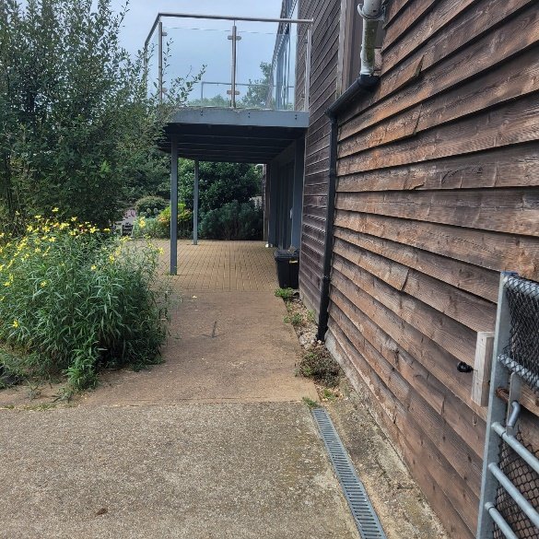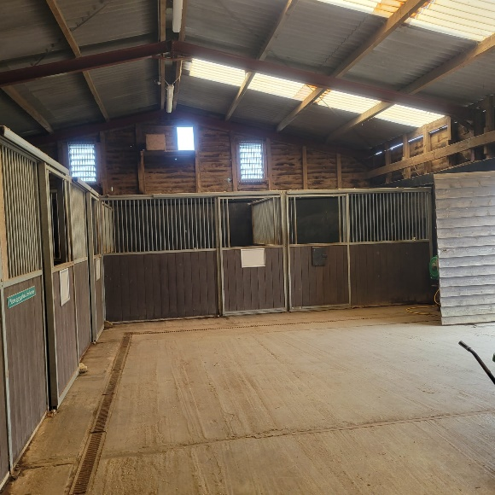
Slope from patio towards the stables The stables
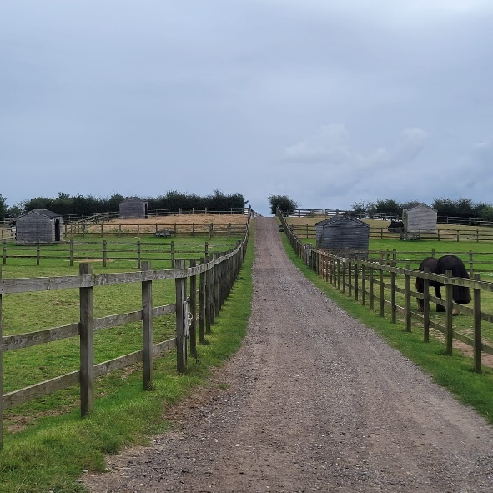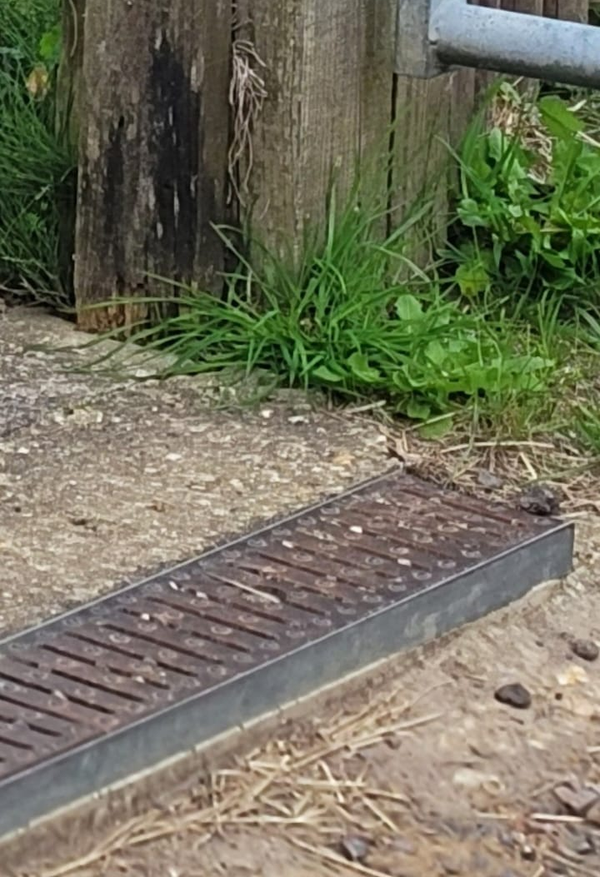
Largest slope at the centre Step into the Memorial Garden
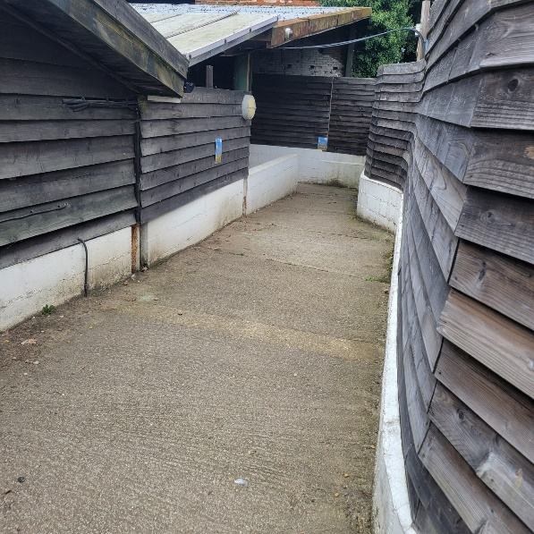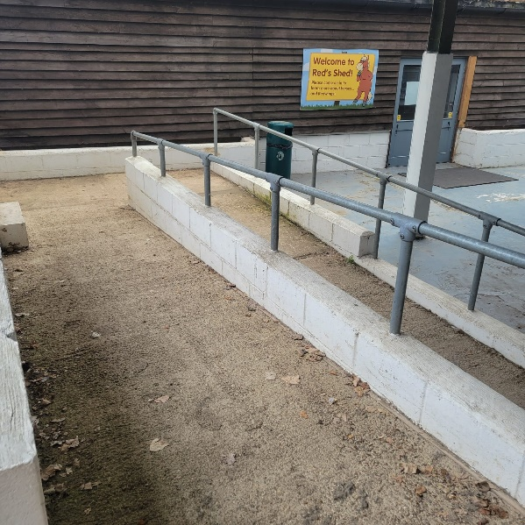
Slope into Red’s Shed Slope into Red’s Shed
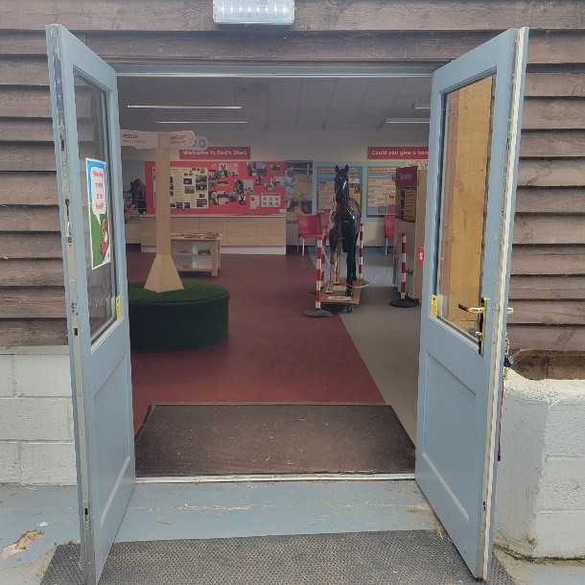
Entrance to Red’s Shed

Additional Information
- There are two Fire Assembly Points – one on the main car park and the other on the fence line past Red’s shed and signposted with a large green/white Fire Assembly sign.
- Staff are trained to assist visitors if an emergency arises.
- There is always first aid trained staff on site and there is a defibrillator located within the Visitor Centre.
- All dogs on leads are welcome on site and water bowls and dog waste bins are provided.
- There is a single smoking point on site in the car park area. No smoking is permitted in any other part of the site.
- Permanent staff are Dementia Friends dementiafriends.org.uk
- Entrance and exit gates are manual. Please arrange staff assistance in advance.

