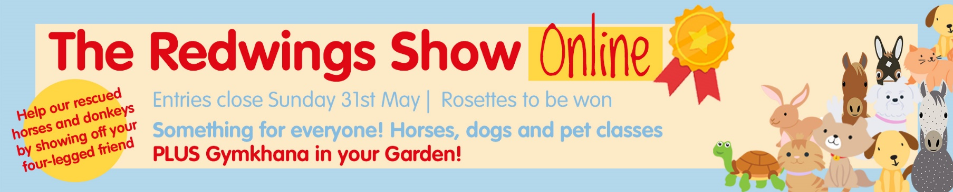

Class Number | Name and age of animal | Name and age of Rider/Handler/Owner
4 | Bailey, 10 | Joe Brown, 24
Please complete the following information about yourself, including your photography and video consent. This must be completed for us to be able to accept your entry.

Your name
Your address (For rosettes and/or prizes to be posted to if you are a lucky winner!)
FAO PARENTS/GUARDIANS Relationship to child(ren)
(if applicable)
Name of child(ren)
(if applicable)
Age of child(ren)
(if applicable)
Please tick to give consent / acknowledge agreement: | I give consent for my photo and / or video to be used for the purposes of all  Redwings promotional and campaigning material (Print, broadcast & online)  I give consent for my name to be used alongside the image  (If applicable) I give consent for my child/children’s photo and / or video to be used  for the purposes of all Redwings promotional and campaigning material  (If applicable) I give consent for my child/children’s name to be used alongside the  image
Signature

Please Note: By sending us your photo (or video) as entry for the Redwings Online Show you are consenting for us to share it with our judges.

We will not sell or share your image(s) with any third parties, except in line with your consent preferences for the purposes of print and postal distribution, for example. However, be aware that Redwings cannot control an image once it is posted online. The data controller is Redwings Horse Sanctuary, Hapton, Norwich, NR15 1SP and we have a Data Protection Officer who can be contacted on dataprotection@redwings.co.uk. For more information on data protection at Redwings, and your data rights, please read our full privacy notice which is available online (www.redwings.org.uk/privacy-policy).

We would like to stay in touch about Redwings’ work rescuing, rehabilitating and providing sanctuary care for horses and donkeys. If you would like to hear from us please indicate below.
I would like to receive:

Newsletters and gift catalogues by post News, appeals and gift shop offers by email
Appeals by post Prize draw tickets* by post for the chance
to win up to £5,000!

*Please note you must by over 16 and a UK resident

You can change your mind at any time: call 01508 481000 or email info@redwings.co.uk to update your preferences. All data is held in accordance with data protection legislation and we promise to only process your data for the purpose for which it was given. Read our full privacy policy at www.redwings.org.uk/privacy-policy or contact us for a copy.

